**Week 2: Network Commands & Tools**

**Objective:** Learn essential networking commands and tools.

**Task#01: Use ping, tracert (Windows), traceroute (Linux), netstat, and nslookup to test and analyze network paths.**

Solution:

**PING:**

The ping command is a fundamental network utility used to **test the reachability of a host** on an Internet Protocol (IP) network. It works by sending ICMP echo request packets to a target and listening for ICMP echo reply packets, thereby **measuring the round-trip time and reporting packet loss**. It works for both IP Addresses and domain names.

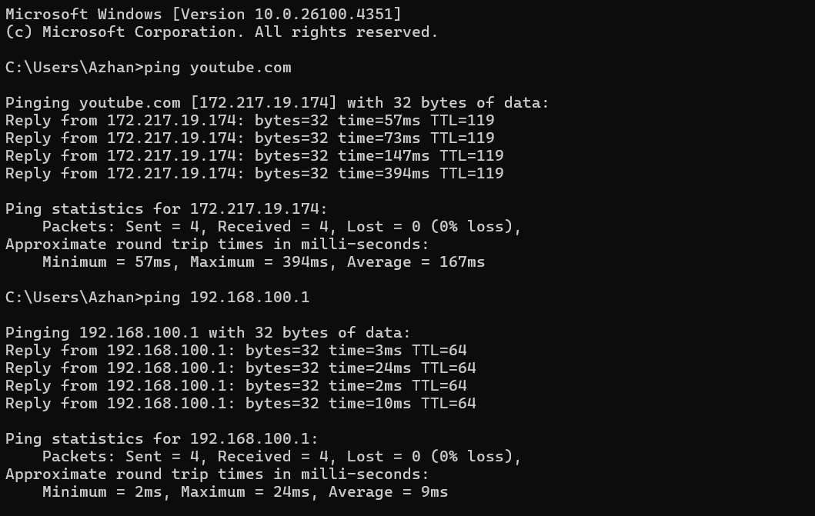

**TRACERT:**

The tracert (traceroute in Linux/macOS) command maps the **path that data packets take** to reach a destination across an IP network. It displays a list of the intermediate routers (hops) that packets travel through, along with the time taken to reach each hop.

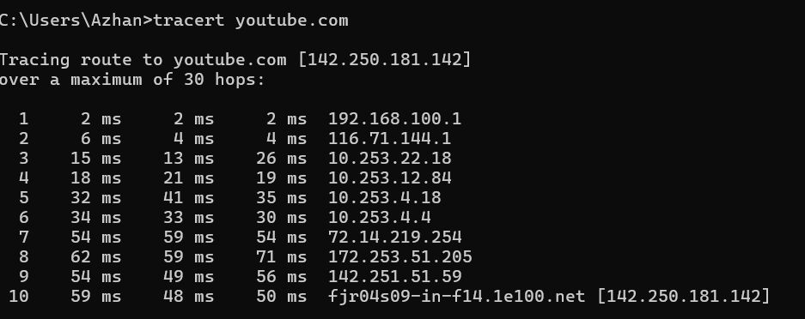

**NETSTAT:**

The netstat command displays **active network connections** (both incoming and outgoing) and **listening ports** on your computer. It's a key tool for monitoring network activity, identifying open ports, and troubleshooting connectivity issues.

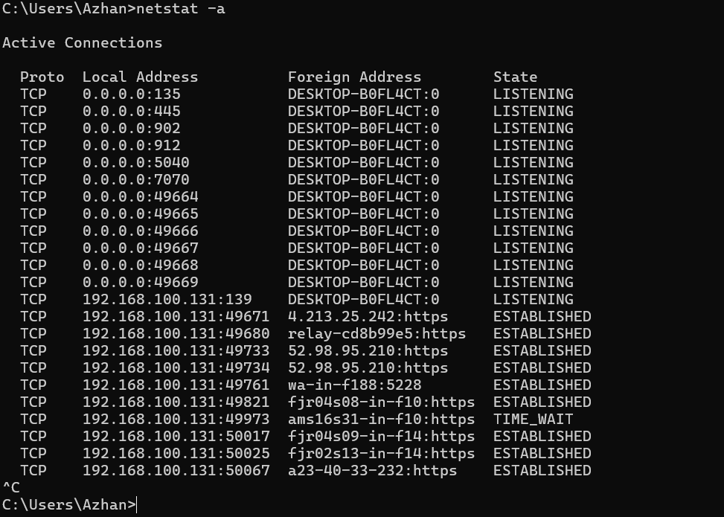

**NSLOOKUP:**

The nslookup command is a network administration command-line tool used for **querying the Domain Name System (DNS)** to obtain domain name or IP address mapping information. It primarily helps in **diagnosing DNS infrastructure problems** and verifying DNS records.

